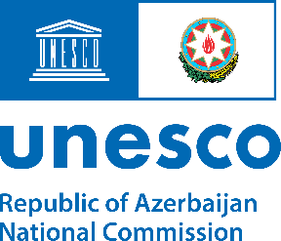
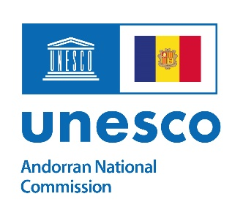
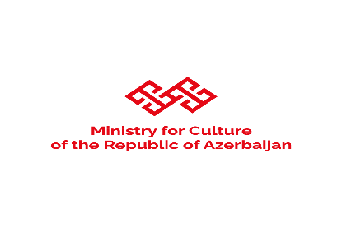

Youth ArtCamp Shusha and Baku 2022
August 26 – September 5, 2022, Shusha & Baku, Azerbaijan

Project Background
One of the most important targets for UNESCO is reinforcing the role of culture as an essential means for promoting peace. In this context, “Road to Peace Programme” of UNESCO targets to promote the concept of living together in peace and to generate dialogue for intercultural understanding. One of the four key pillars of the respective programme is capacity building for fostering transformative change in attitudes and behavior through certain existing initiatives, such as ArtCamp project. In particular, the ArtCamp project, that was first launched in Andorra, in 2008 under the patronage of UNESCO is regarded as an essential tool to foster and promote dialogue for peace between artists from all over the world and to strengthen the educational dimension of culture. In particular, the ArtCamps are a cross-cultural meeting in which artistic expressions are the common universal language and a place where artists from different parts of the world are able to share their cultures, ideas and perceptions within a wide range of activities and experiences, which contributes to their art works.
Within the framework of “Road to Peace Programme” of UNESCO, Ministry for Culture of the Republic of Azerbaijan in collaboration with National Commission of the Republic of Azerbaijan for UNESCO and National Commission of Andorra for UNESCO aims to contribute to the ArtCamp Project through organizing another ArtCamp in Shusha and Baku cities of Azerbaijan. The Youth ArtCamp Shusha and Baku is an artist-residency project organized to provide an opportunity for the guest artists to work in historical and natural sites of the country and to produce artistic works through communicating and exchanging their ideas and thoughts with each other.

Project Objective
In the ArtCamp, the guest artists from foreign countries will work together, exchange their ideas and thoughts and understand each other, while using art as a common medium of communication. In this context, the primary objective of the ArtCamp project is to arrange a showcase of art works for guest artists and to promote the fundamental values embraced by UNESCO, including the sustainability of peace and the protection and promotion of the diversity of cultural expression. Accordingly, the principal aim of the project is to further reinforce the role of culture as critical means in sustainable education and promotion of peace through art.

Structure of ArtCamp Project
The ArtCamp will be held in Shusha and Baku cities of Azerbaijan. Throughout the camp, there will be field trips to historical sites in Baku, Shusha, Aghdam, Fuzuli and Jabrayil cities of Azerbaijan. The camp will be organized by Ministry of Culture of the Republic of Azerbaijan. The ArtCamp will cover a period of 10 days. The camp will be organized under the patronage of Ms. Hedva Ser, UNESCO Goodwill Ambassador. There will be 20 young painters participating in the ArtCamp. All participation costs for the guest artists and visitors, including airfare tickets will be covered by Ministry for Culture of the Republic of Azerbaijan. The language of instruction throughout the ArtCamp is English.
Eligibility Criteria
- Young artists aged between 18 and 35;
- Applicants shall submit electronic versions of their last two art works

Application Process
Applicants are to be nominated by UNESCO National Commissions of those countries that have resident diplomatic missions accredited to Azerbaijan and individual applications will not be considered. Please, be informed that only accepted candidates will be contacted.
For further information about application process, please contact:
Ms. Afsana Huseynova, Second Secretary, National Commission of The Republic of Azerbaijan for UNESCO
Email: ash_huseynova@mfa.gov.az
Tel: (+994) 12 596 93 54; (+994) 12 596 93 88

The list of documents to be submitted by candidates:
- Application form
- Passport copy
- Curriculum Vitae
- Electronic version of passport size photo
- Electronic versions of the last 2 art works
- COVID-19 Vaccine Passport / immunity certificate

Application Timeline
- Application period: June 10 - 30, 2022
- Review and process: July 1 – 10, 2022
- Sending of Acceptance letters: July 11-15, 2022

Activities
The programme of Youth ArtCamp Shusha and Baku will include excursions to historic sites of Azerbaijan in Baku, Shusha, Aghdam, Fuzuli and Jabrayil. Moreover, the camp will also be an opportunity for painters from various countries to present their artistic creations, as well as culture of their country (music, dance, costumes etc.).

